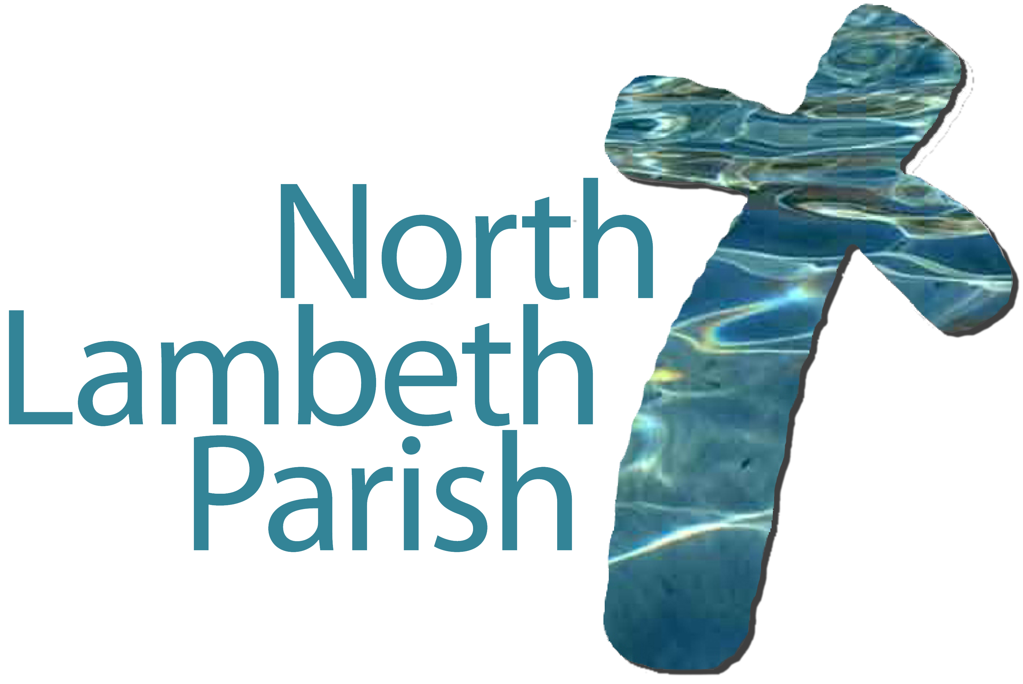
Application for Baptism

At which church would you like the baptism to take place?

St Anselm’s Church, Kennington SE11 5DU

St Peter’s Church, Vauxhall SE11 5HY

Please state preferred month for baptism___________________________________

Child’s Details

Date of Birth | Christian Name(s) | Surname | Gender

Parents’ Details

 | Full name and address | Phone number and/or email address | Occupation | Have you been
 |  |  |  | baptised? | confirmed?
Mother
Father

Godparents’ Details

 | Full name | Address | Has s/he been….
 |  |  | baptised? | confirmed?
1.
2.
3.

Please return this form to:
NLP Office, Centenary Hall, Cottington Street, Kennington, SE11 4RZ or jenny.morgans@gmail.com.
A member of the team will contact you to confirm the date of the baptism and arrange to visit you.

